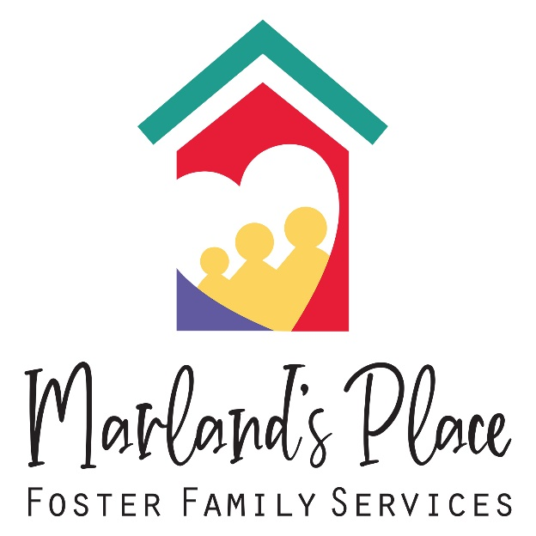
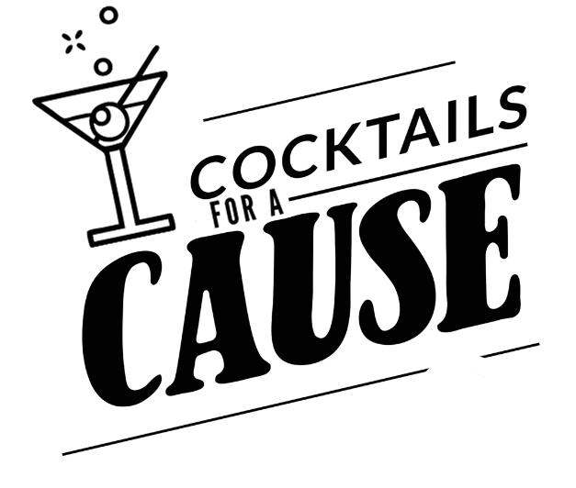
Company Name:
_______________________________________________
Contact Name:
_______________________________________________

Contact Number:
_______________________________________________

Email Address:
_______________________________________________

Address:
_______________________________________________

City: ____________________ State: ______ Zip: ________

(Circle One)

Concert Grand Grand Baby Grand Studio

Other Amount: _________

*Marland’s Place is a 501©3 tax exempt organization and your donation may be tax deductible. Receipt will be provided upon receiving funds.
Friday, April 10th, 2026
Join us for a night out as Dueling Pianos return for a fun evening of live entertainment! Each ticket includes two drink tickets, hors d’oeuvres, and the opportunity to support the life of a child in care. Doors open at 7:30 PM. The show begins at 8:00 PM and concludes at 10:30 PM.
Concert Grand ($5,000 Donation)
Supports a full year of extracurricular activities for 20 children, opening the door to art, music, sports, etc.
  - Same as Grand, Plus:
  - Company logo on website event page
  - (2) Reserved tables
  - (16) event tickets with (2) drink tickets per person
Grand ($2,500 Donation)
Provides every foster child receives a birthday gift, making their day extra special
  - Same as Baby Grand, Plus:
  - Reserved table
  - (8) event tickets with (2) drink tickets per person
Baby Grand ($1000 Donation)
Provides new clothing for 8 children entering foster care.
  - Same as Studio, Plus:
  - Company logo displayed at the event
  - (4) event tickets with (2) drink tickets per person
Studio ($500 Donation)
Provides essential school supplies for 5 children on their educational journey at a new school.
  - Company highlight on social media
  - Company name listed on the event page
  - (2) event tickets with (2) drink tickets per person
  - Complimentary hors d’oeuvres all night

